1.Concept of Ultraviolet C (UVC) light

Ultraviolet C light has the ability to destroy viruses and bacteria by disrupting them at a cellular level. However this is dependent on the dose, time and distance of the light from the object. Importantly, evidence has emerged from the American Journal of Infection Control in 2020 that it is effective against the Coronavirus ( American Journal of Infectious Disease, 2020)

There is a clear distinction between the scientific use of UVC light for these purposes and merely commercial use for profit. For ethical and professional reasons, this technology must be developed in conjunction with adequate research and development as well as thorough laboratory testing to ensure its effectiveness given the magnitude of risk involved in working in the healthcare industry.

This technology is also extremely useful against hospital acquired infections, one of the leading causes of death and disability globally. The WHO predicts that in the USA alone 1.7 million people get a hospital acquired infection each year and this number increases to 30 % of all admissions when focusing specifically on ICUs. THis burden is predicted to be even high in low and middle income countries, however there is currently insufficient surveillance to provide accurate data on the actual numbers (WHO, 2020).

1.1.Types of UV light

- UVA light has the lowest amount of energy. When you’re out in the sun, you’re mainly being exposed to UVA light. Exposure to UVA light has been linked to skin aging and damage.
- UVB light sits in the middle of the UV light spectrum. A small portion of sunlight contains UVB light. It’s the main type of UV light that contributes to sunburns and causes most skin cancers.
- UVC light has the most energy. UVC light from the sun is mostly absorbed in the Earth’s ozone, so you’re not normally exposed to it on a daily basis. However, there are various human-made sources of UVC light. (Healthline, 2020)

There are generally two types of production for UVC, one uses mercury and is the traditional method and the other does not use mercury but rather uses a light emitting diode commonly known as a LED. LEDs have become common place as newer technology in lighting that uses less electricity, lasts longer and is more environmentally friendly because it does not use mercury. However, LEDs are still fairly new when it comes to UVC so there are certain manufacturers that do UVC LEDS to medical grade quality. Our manufacturer for prototypes was Klaran which partners with Crystal IS to produce the latest technology for UVC LED for disinfection across sectors (Klaran, 2020).

1.3.Mercury based UVC versus LED UVC

UVC LEDs have many advantages:

- Compact
- Durable
- More efficient than normal UVC mercury lamps
- Low maintenance
- Not environmentally harmful to dispose of

Why is mercury/quicksilver harmful?

The World Health Organization has published a list of the following known harms of mercury:
- Exposure to mercury – even small amounts – may cause serious health problems, and is a threat to the development of the child in utero and early in life.
- Mercury may have toxic effects on the nervous, digestive and immune systems, and on lungs, kidneys, skin and eyes.
- Mercury is considered by WHO as one of the top ten chemicals or groups of chemicals of major public health concern.
- People are mainly exposed to methylmercury, an organic compound when they eat fish and shellfish that contain the compound (WHO, 2020).

2.What is our solution

We use high-quality light-emitting diodes produced by one of the most reputable UVC LED providers, Klaran. This makes it possible to curb the spread of infectious disease in a way that does not use mercury or any other harmful chemicals.

The rise of infectious disease worldwide has created a need for new and innovative ideas to create healthier, safer environments. BioRayz does just that. By harnessing the unique power of ultraviolet light to kill 99 % of bacteria and viruses BioRayz has designed a box for disinfection of commonly dirty items like your phone, mask and keys. We use brand new technology that’s not just good for cleaning, but also good for the environment. We use UVC LED lights in our technology to replace the traditional mercury UVC lamps that are harmful to human health and extremely dangerous in the environment. An added bonus is that UVC LEDs last longer, are more efficient and are safe to use. UVC LEDs have a large potential to completely disrupt the traditional UVC market and we are looking to create more products that add value to society by decreasing the spread of infectious diseases in crowded settings, the medical industry and for individuals.

Our original prototype focused on a box that disinfected everyday items that everybody used. However, our second prototype focused on a box that is specifically for healthcare workers for their masks, phones, stethoscopes, keys etc as these items were common points of transmission of infectious disease in healthcare settings.

3.Prototype One
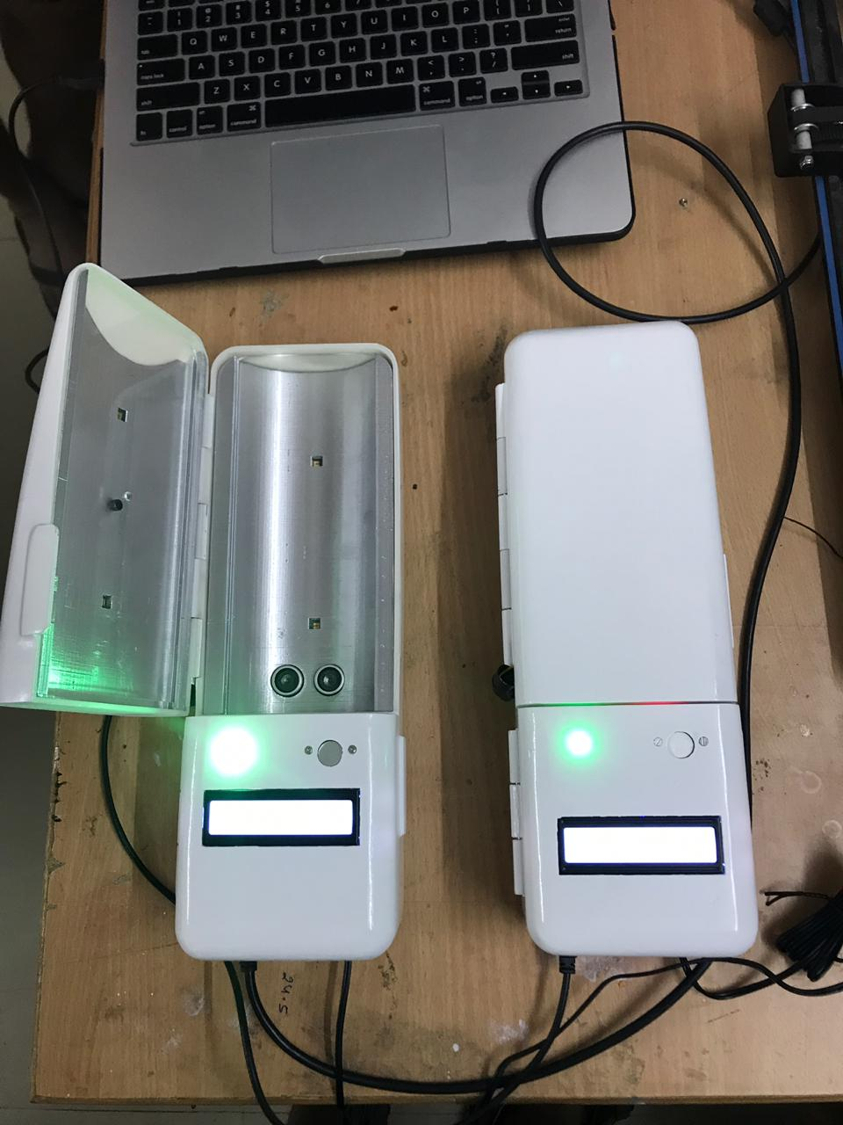
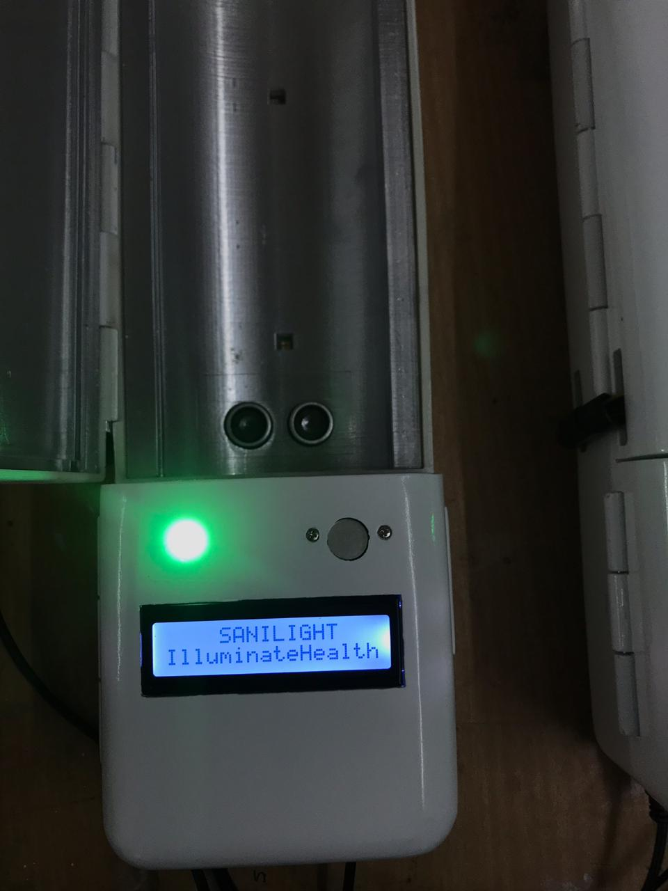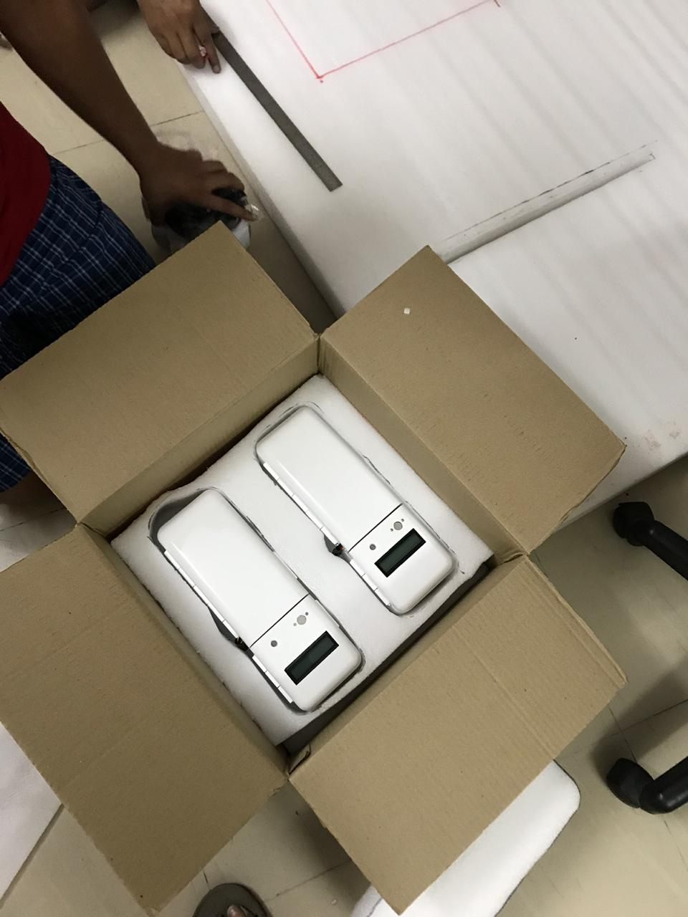

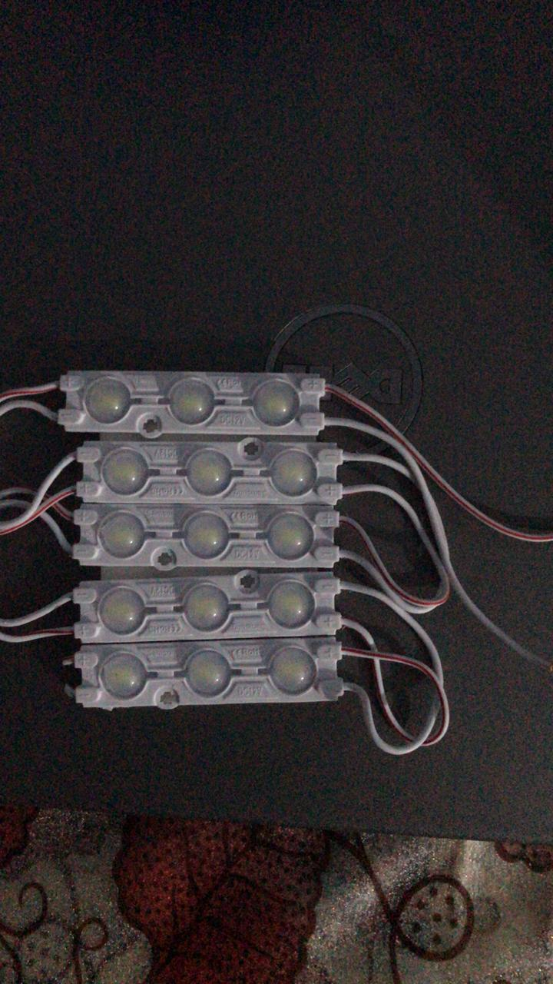

3.1.Prototype two

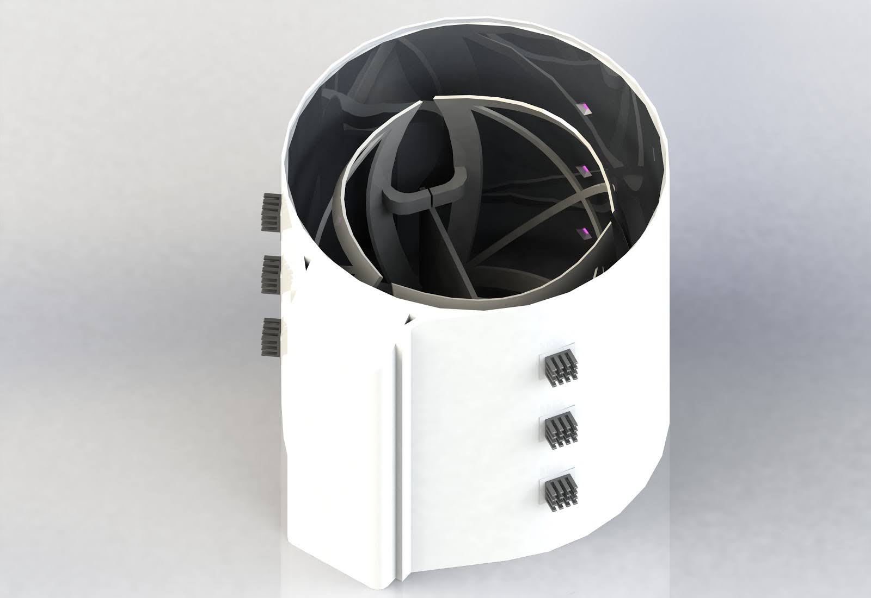

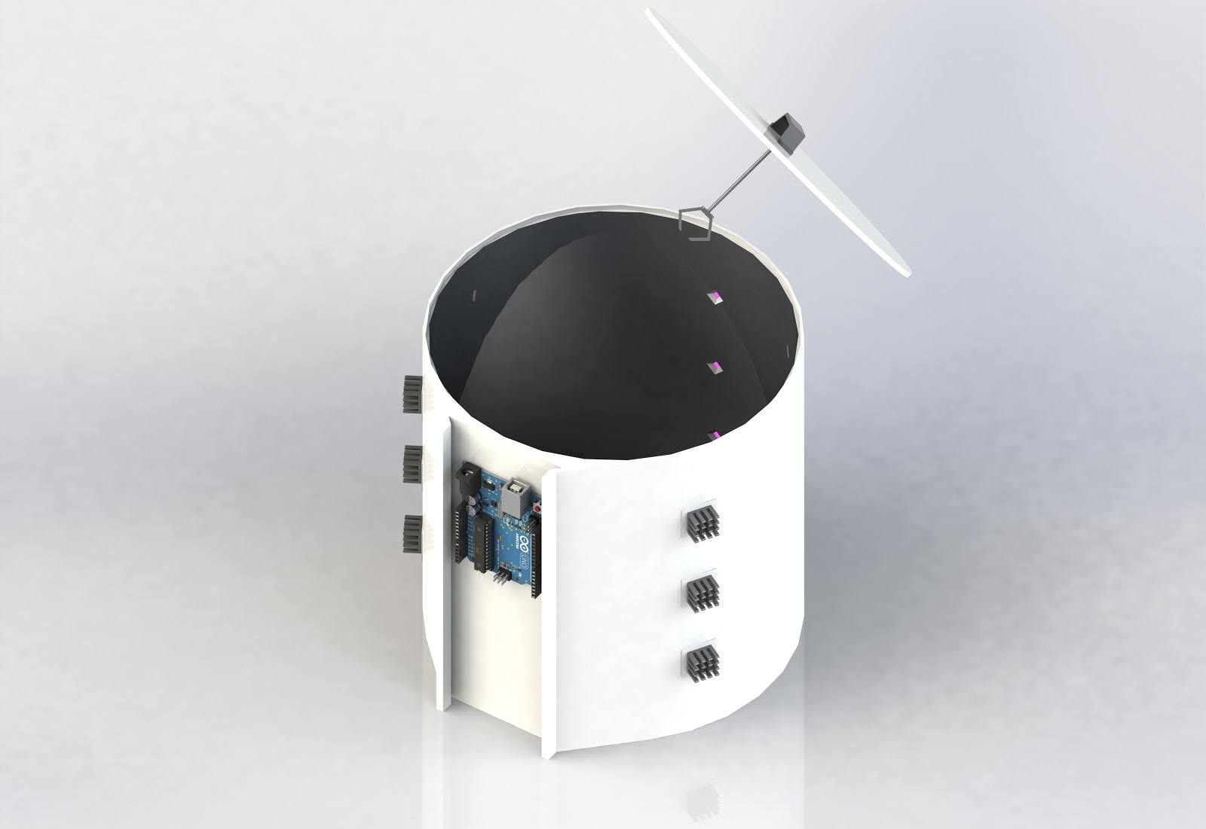

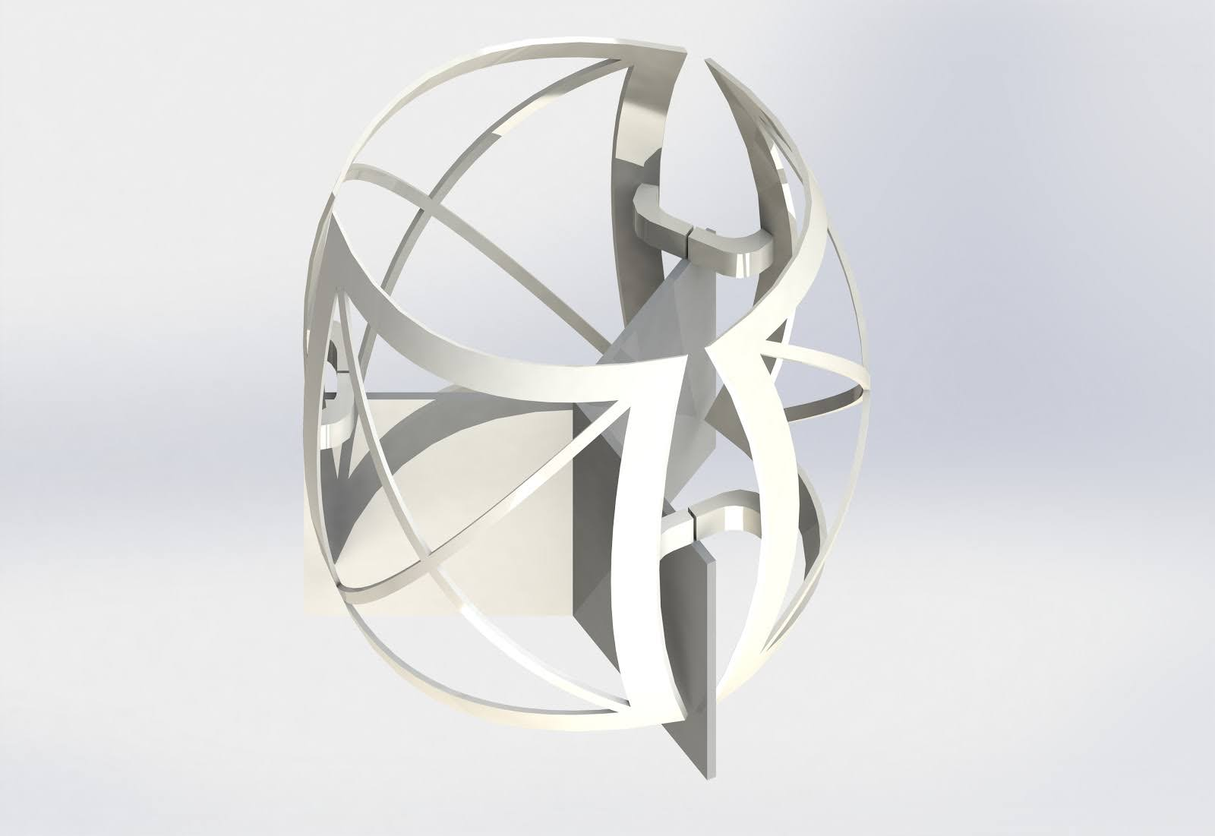

4. Expertise needed

- Engineering expertise: mechanical, electrical, software
- Medical or healthcare worker expertise to inform design
- Marketing expertise to convey purpose
- Finance/administration

5.Further development

The box will need to have appropriate space for the items required but importantly it should facilitate a 360 degree light penetration of the object ( ie no blinc spots or shadows to ensure complete disinfection.) The object must be exposed for a predetermined amount of time to the strength of UVC required. Klaran can assist in helping determine the amount of LEDs needed for the time and distance variables. It should ideally be lightweight and have a mechanized component for opening and avoid cross infection at this site. If electrical supply could come from USB or rechargeable batteries that would be ideal for low income settings without stable electricity supply.

